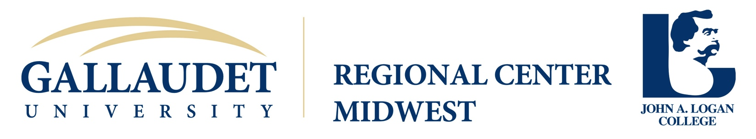

Sponsorship Request Form

Thank you for contacting the Gallaudet University Regional Center (GURC) at John A. Logan College regarding your event needs. The GURC considers sponsorship in the 13 states that are covered by the Midwest region (IL, IA, IN, KS, KY, MI, MO, MN, NE, ND, OH, SD, and WI) which are in keeping with the mission as set forth by Gallaudet University. Our mission is to address the educational, transition, and professional development needs of deaf and hard of hearing people from birth through adulthood, their families and the professionals who work with them.

If the focus of your event meets the criteria as stated above, please complete this sponsorship form and email it as an attachment to shericook@jalc.edu. Once we have received your completed application and have made a determination, you will be notified.

If we agree to any financial support, we will need the following items completed and sent to us within 14 calendar days after your event (postmarks accepted).

1. Attendance Form section (see below)
2. Evaluation‐ If your event will pass out evaluation forms, we will need copies of them

We look forward to the possibilities of working with you and your organization.

Form must be submitted for review at least four (4) weeks in advance

I. Contact Information:
Requesting Organization:

Contact Name: |  | Title:
Mailing Address:

City: |  | State: | Zip:
Telephone/VP Number: |  | Fax Number:
E-mail Address: |  | Web site:
Conference Title (if applicable)

Activity Site (City/State)

.
II. Sponsorship and Event Information:
Focus of Event

Please list the exact date(s) of the event: | What is the expected number of attendees?
Target Audience

Conference/Activity Website

What type of assistance are you requesting?  Financial, amount __________________  Who do we write the check out to?  To cover  Materials (Specify): |  | Contacting Speaker(s)  Do you have a speaker in mind? If so, who?  If not, what topic(s) are you interested in?  Accommodations (Interpreters, CART, etc.)

III. Advertising Information:
Will you offer logo placement on the Web? | Yes No
Will you have a program book? | Yes No
Will you offer GURC at John A. Logan College an ad placement? | Yes No
File format to be delivered (.JPEG, .PDF, etc.)?
What is the deadline for ad submission?

VI. Additional comments, questions and requests:

700 Logan College Road ▪ Carterville, IL 62918
(618) 565-0054 (VP) ▪ 618-985-9181 fax ▪ www.jalc.edu/gurc

Attendance Form

Please fill out the entire form and submit them to shericook@jalc.edu within 14 days after your event.

Target Audience (specify actual attendance)

Teachers (all types of teachers) ______________
Support Personnel (i.e. audiologist, teacher’s aide, counselors, assistants, etc.) ______________
Residence Personnel ______________
Administrators (all types of administrators) ______________
Parents ______________
Students (birth – middle school) ______________
Students (high school) ______________
Students (postsecondary) ______________
Other: ____________________ ______________
Other: ____________________ ______________
General Public ______________

Total Attendance ______________
Total number of Deaf/Hard of Hearing ______________

